|  |  |
| --- | --- |
| AECHE2020  **Narrogin SHS Year 11 ATAR CHEMISTRY Name:** | |
| Task No: | 1 |
| Task Type: | Test |
| Content: | Atoms and elements |
| Task Description: | Complete the attached questions on the multiple choice answer sheet or in the spaces provided.  Marks will be awarded for presentation and working.  **Test conditions (50 minutes).**  *Formulae and data booklet provided.*  *Non-programmable calculator permitted.* |
| Total Marks: | 27 |
| Weighting: | 2.1% |
| Due Date: | 12 Feb 2020 |



**Multiple Choice Answer Sheet**

**Task Number: __ Name: _______________ Year: __**

**Multiple Choice – 12 questions.**

Circle your choice. If you change your mind, cross out your choice out and circle the one you want. If it is messy, clearly write your choice next to question.

1. A B C D

2. A B C D

3. A B C D

4. A B C D

5. A B C D

6. A B C D

7. A B C D

8. A B C D

9. A B C D

10. A B C D

11. A B C D

12. A B C D

**Section 1: Multiple Choice**

*Indicate your answers on the multiple choice answer sheet*

1. Which of the following statements regarding atomic particles is false?
2. Protons are found in the nucleus and are positively charged particles.
3. Electrons move around the nucleus and contribute little to the mass of the atom.
4. Neutrons are found in the nucleus and they have no charge.
5. The numbers of neutrons, protons and electrons are always equal in a neutral atom.
6. The species contains
7. 12 protons, 12 neutrons and 12 electrons
8. 12 protons, 12 neutrons and 14 electrons
9. 12 protons, 10 neutrons and 10 electrons
10. 12 protons, 12 neutrons and 10 electrons
11. The numbers of protons and neutrons of four atoms J, K, L and M are given in the table below

|  |  |  |
| --- | --- | --- |
|  | PROTONS | NEUTRONS |
| J | 6 | 7 |
| K | 6 | 8 |
| L | 7 | 8 |
| M | 8 | 8 |

Which of these pairs are isotopes of the same element?

1. J and K
2. K and L
3. J and M
4. L and M
5. With respect to *178O* which of the following statements is correct?
6. The atomic number is 9.
7. The number of neutrons is 9.
8. The mass number is 25.
9. The atomic weight is 9.
10. An ion is best described as
11. an group of atoms that has given away electrons
12. an atom that has given away protons, causing it to become radioactive
13. a type of isotope
14. an electrically charged species, formed when atoms or groups of atoms gain or lose electrons
15. An atom has 21 protons, 22 neutrons and 18 electrons. It is
16. an ion of titanium
17. a neutral atom of titanium
18. an isotope of calcium
19. an ion of scandium
20. Which of the following statements concerning the two isotopes of helium, and , is false?
21. Both of these atoms would behave in exactly the same manner in a chemical reaction.
22. The atoms differ only in their mass, atoms being heavier thanatoms.
23.  atoms have an extra proton compared to atoms.
24. In nature,  atoms are more abundant than  atoms.
25. The most obvious difference between Dalton’s ‘Billiard Ball’ model of the atom and Thomson’s ‘Plum Pudding’ model which followed it was that
26. Thomson used experiments to support his model.
27. Thomson’s atoms were divisible.
28. Dalton’s atoms were hard and Thomson’s atoms were soft.
29. Dalton’s atoms contained neutrons.
30. The electron configuration: 2, 8, 4 is that of
31. Carbon
32. Nitrogen
33. Neon
34. Silicon
35. Electrons are thought to be located in distinct energy levels or shells in an atom. The maximum number of electrons which can be found in the second (n=2) shell of an atom is
36. 2
37. 8
38. 18
39. 36
40. Study the diagram below which shows an emission spectrum of four gases and a mixture of gases.

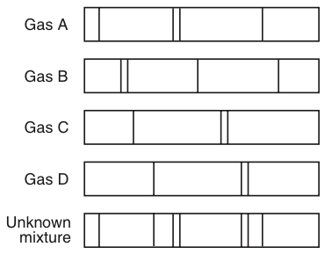

The mixture contains

1. Gas A and B
2. Gas A and C
3. Gas B and C
4. Gas A and D
5. The diagram below shows a Cathode Ray Tube.

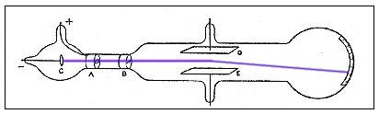

The Cathode Ray Tube was used by JJ Thomson to demonstrate the existence of

1. isotopes
2. neutrons
3. electrons
4. orbitals

**Section 2: Short Answer**

*Write your answer in the spaces provided*

1. Tritium is an isotope of hydrogen with a mass number of 3.

1. Indicate the number of protons, neutrons and electrons for a neutral atom of tritium.

proton(s) __________

neutron(s) __________

electron(s) __________ (3 marks)

1. Show the IUPAC symbol for this isotope.

(1 mark)

1. Write the electron configurations (shell only) for the following
2. Ca ____________________________________________________
3. O ____________________________________________________
4. Li+ _____________________________________________________

(3 marks)

1. Study the mass spectrograph below:

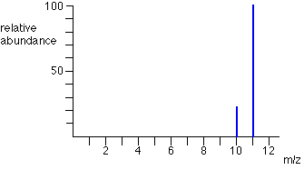

25%

75%

1. Determine the relative atomic mass of the sample (3 marks)
2. Suggest the identity of the element being analysed (1 mark)
3. Briefly explain Rutherford’s ‘Nuclear’ model of the atom, using a diagram if necessary. Identify one piece of evidence (or one experiment) which supported this model over Thomson’s ‘Plum Pudding’ model. (4 marks)

**END OF TEST**